WNBA Great Group Reads 2025–2026
A Curated Collection for Book Clubs and Readers Everywhere

Introduction
Welcome to the Women’s National Book Association’s Great Group Reads 2025–2026 selections. Each year, our committee carefully reviews a wide range of titles to identify works that spark meaningful conversation, represent diverse voices, and inspire readers everywhere. This media kit provides book blurbs, covers, and key information for each selection, making it easy to share with book groups, libraries, and media partners.

The Calamity Club

Kathryn Stockett - Spiegel & Grau
HC 9781954118812
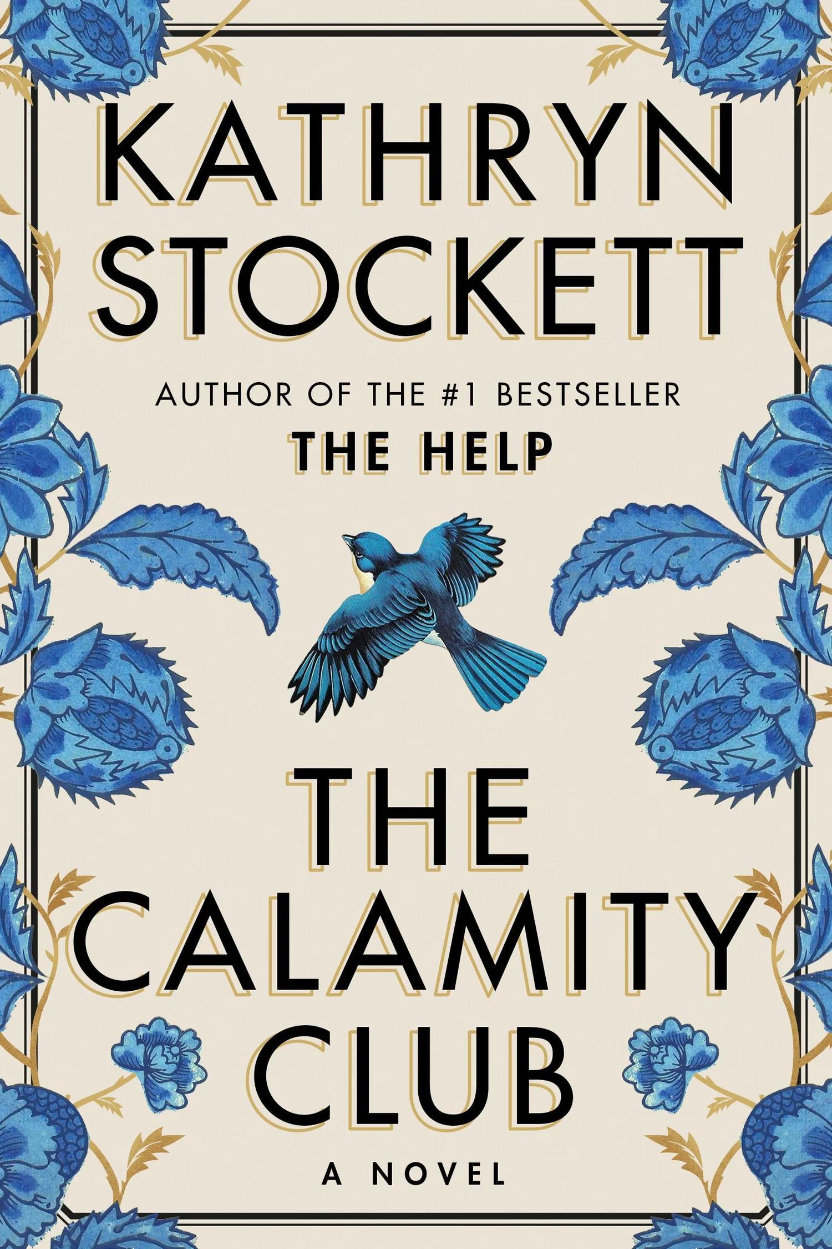
Set in Depression-era Mississippi, The Calamity Club follows three unforgettable women whose lives intersect in unexpected ways. Eleven-year-old Meg, abandoned by her mother and living in an orphanage, has learned to depend on herself. Birdie, an outspoken young woman struggling to save her family's farm, discovers that her wealthy sister's seemingly perfect life hides troubling secrets. Charlie, a woman with little left to lose, brings an unexpected opportunity for change. As their stories converge, these unlikely allies challenge the expectations and injustices of their time. Blending humor, heartbreak, and Southern storytelling, Kathryn Stockett delivers a spirited novel about friendship, resilience, and the extraordinary things ordinary women can accomplish together.
Why it’s a Great Group Read
The Calamity Club offers book clubs a compelling exploration of women's friendships, found family, resilience, and survival during the Great Depression. Through its memorable characters and their interconnected lives, the novel invites readers to examine motherhood, sacrifice, social inequality, and the extraordinary strength of women supporting one another. Its historical setting opens the door to important discussions about race, sexual orientation, the treatment of children in orphanages, and the discriminatory laws and social expectations that restricted women's lives. Blending humor and heartbreak, the story offers a rich examination of courage, loyalty, and the difficult choices people make in the face of adversity. The author's notes provide additional historical context, making this an especially rewarding selection for groups interested in exploring the connections between historical injustices and contemporary society.

The Only Way Out is Through

Tara Weinstein - Blair Publishing
PB 9781958888810

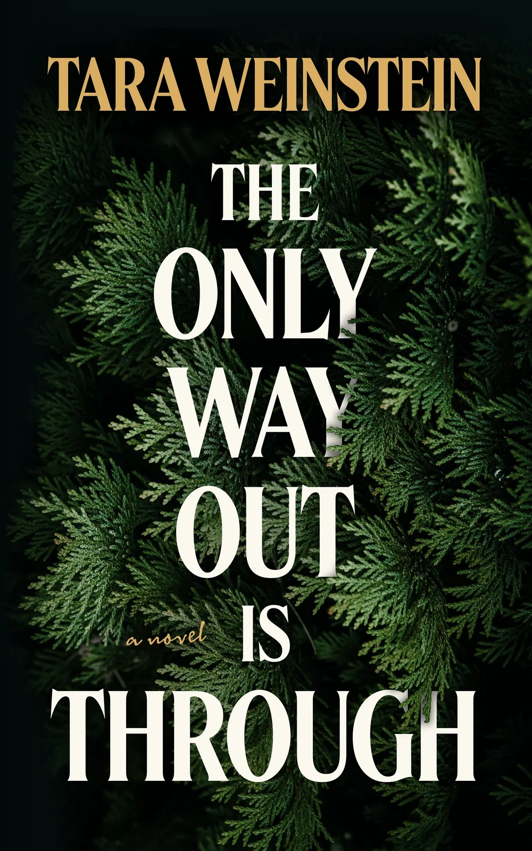
Abducted at the age of five and returned to her family ten years later, Bria Singer has spent much of her life at the center of a story everyone seems to know but few truly understand. Now twenty and living in New York City, Bria struggles to establish an identity beyond her extraordinary childhood and reconnect with a family forever changed by her disappearance. Through journal entries, newspaper clippings, and relationships with other survivors, she begins piecing together her past while searching for a place to belong. In this suspenseful and emotionally compelling debut, Tara Weinstein explores the complexities of trauma, family, identity, and the difficult journey toward reclaiming one's own story.

Why it’s a Great Group Read
The Only Way Out Is Through offers book clubs a compelling exploration of identity, trauma, resilience, and the complicated meaning of family. Bria's journey raises thought-provoking questions about the lasting effects of childhood abduction, the conflicting emotions surrounding her relationships with both families, and the challenges of rebuilding a life after extraordinary circumstances. Her experiences invite discussions about the value of therapy, friendship, and human connection, as well as the often-overlooked impact of trauma on parents and siblings. The novel's inventive narrative structure, weaving together multiple perspectives, timelines, and newspaper accounts, encourages readers to question how stories are told and whose version of events shapes our understanding. Above all, Bria's search for identity and belonging invites readers to reflect on their own experiences of overcoming adversity and consider the novel's central question: Is the only way out truly through?

Inharmonious

Tammye Huf - Blackstone Publishing
HC 9798874868376

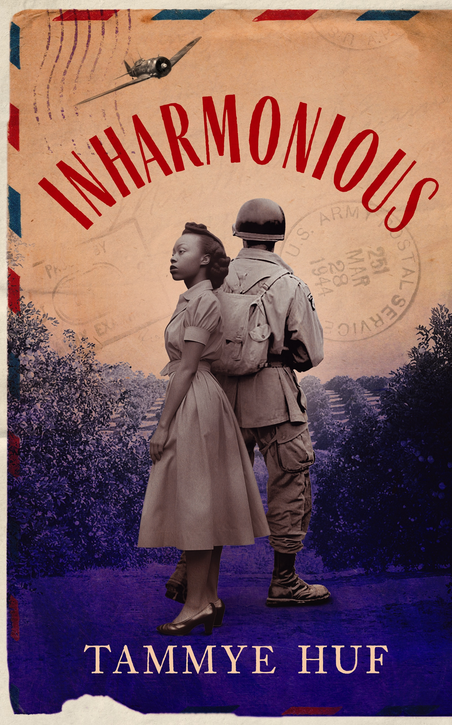
Inspired by the author's own family history, Inharmonious is a powerful story of love, identity, and injustice set in the segregated American South during and after World War II. Following the attack on Pearl Harbor, three young Black men enlist in the Army, hoping to serve their country and secure a better future. Among them is Benny, whose light skin leads to his assignment to an all-white military unit, forcing him to confront difficult questions about his racial identity. Meanwhile, his sister Cora faces her own struggles as the men she loves leave for war. As their lives unfold against the backdrop of a deeply divided America, each must navigate the conflicting demands of family, loyalty, love, and survival.

Why it’s a Great Group Read
Inharmonious offers book clubs a powerful exploration of racial injustice, identity, family loyalty, and resilience during World War II and the Jim Crow era. Through its richly developed characters and compelling historical setting, the novel examines the contradictions of a nation that asked Black Americans to fight for freedom abroad while denying them equality at home. Readers will find much to discuss about segregation in the military, racial identity and passing, the strength of women and families, and the lasting economic consequences of discriminatory policies, including unequal access to GI Bill benefits and homeownership. The characters' experiences invite conversations about personal courage, authentic identity, and the choices individuals make when confronting injustice. The novel also encourages readers to consider how historical inequalities continue to shape American society today. Drawing on the author's family history and extensive research, Inharmonious combines unforgettable characters with important historical insights. The author's historical notes and included discussion questions provide additional resources for thoughtful and engaging book club conversations.

The Reservation

Rebecca Kauffman - Counterpoint, LLC.
HC 9781640097483
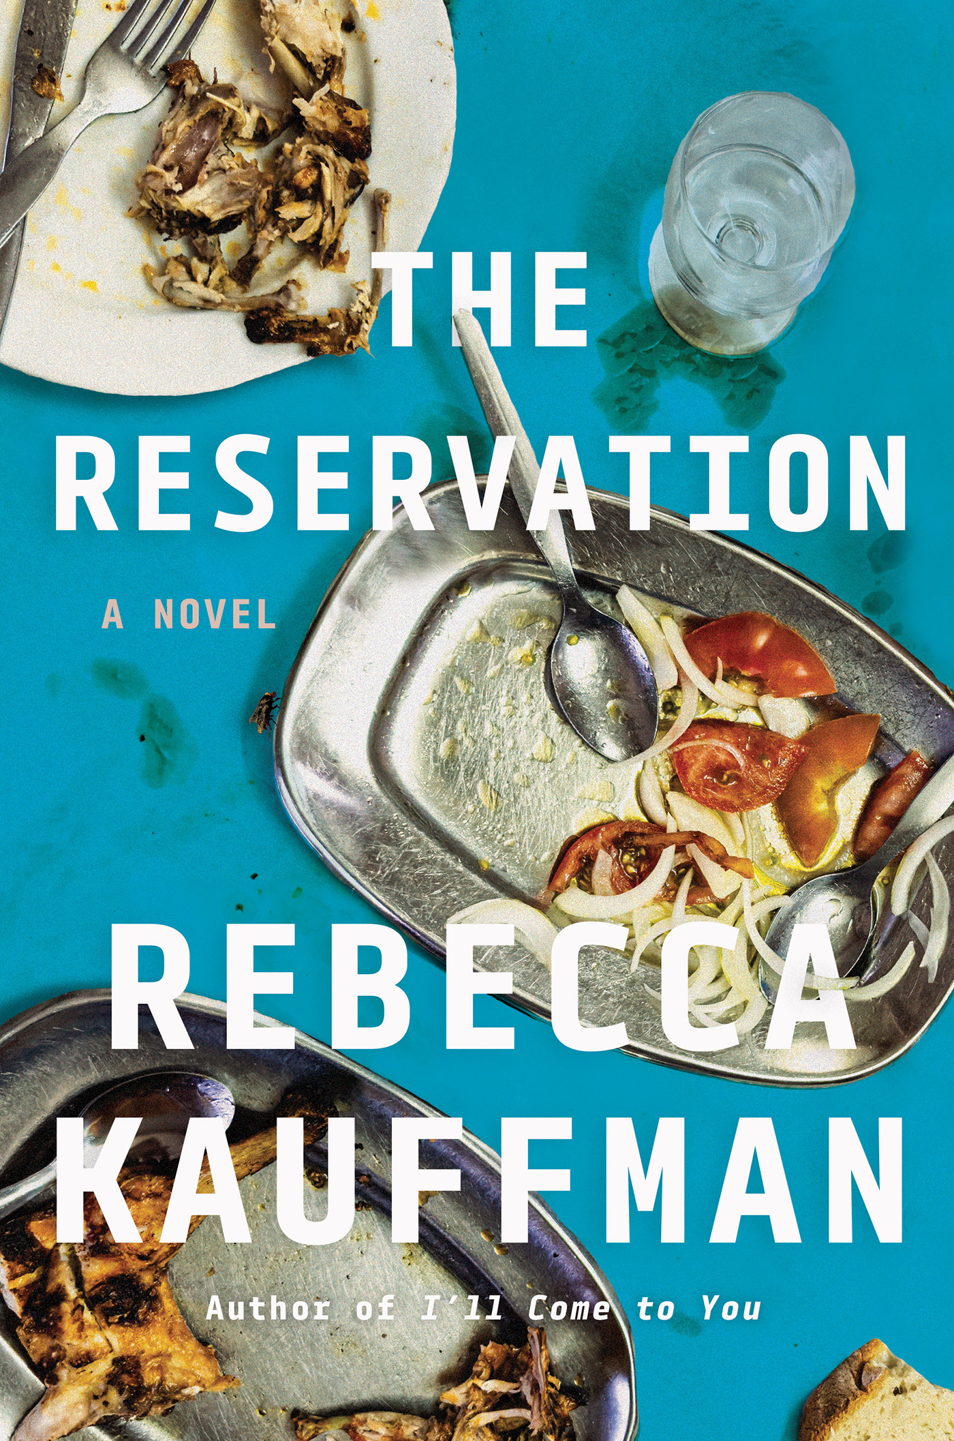
On the morning of the most important booking in the long history of the celebrated restaurant, Aunt Orsa's erupts into chaos with the discovery that twenty-two rib eye steaks have been stolen. Hers is the most august of fine-dining establishments in this Midwestern college town, and tonight Orsa is set to host a large party honoring a very special guest--a bestselling author of national renown. And what's up with the recent spate of online reviews, from insulting to frankly terrible? Is Orsa, who wants only to be loved, being sabotaged on several fronts? No one is above suspicion, not the Mennonite baker nor the tattooed hard-ass chef de cuisine. Could the culprit be among the servers, or even the inexperienced undergrad working as hostess?

Why it’s a Great Group Read
The Reservation offers book clubs a refreshing combination of humor, mystery, and engaging character-driven storytelling. Set against the lively backdrop of a fine-dining restaurant, the novel takes readers behind the scenes to explore the complicated lives and relationships of its employees. Its distinctive structure, with chapters highlighting different characters, invites readers to examine how personal histories, individual perspectives, and workplace dynamics influence our understanding of others. Beneath the entertaining mystery lie thoughtful themes of loneliness, belonging, second chances, and the universal desire for human connection. Readers will enjoy discussing the characters' motivations, unraveling the mystery, and discovering the unexpected challenges faced by people whose lives might otherwise go unnoticed. With its culinary setting, colorful ensemble, and balance of humor and heart, The Reservation demonstrates that a lighter read can still inspire lively and rewarding book club conversations.

Murder Most Delicious

Danielle Postel-Vinay - Harper Perennial
PB 9780063470132
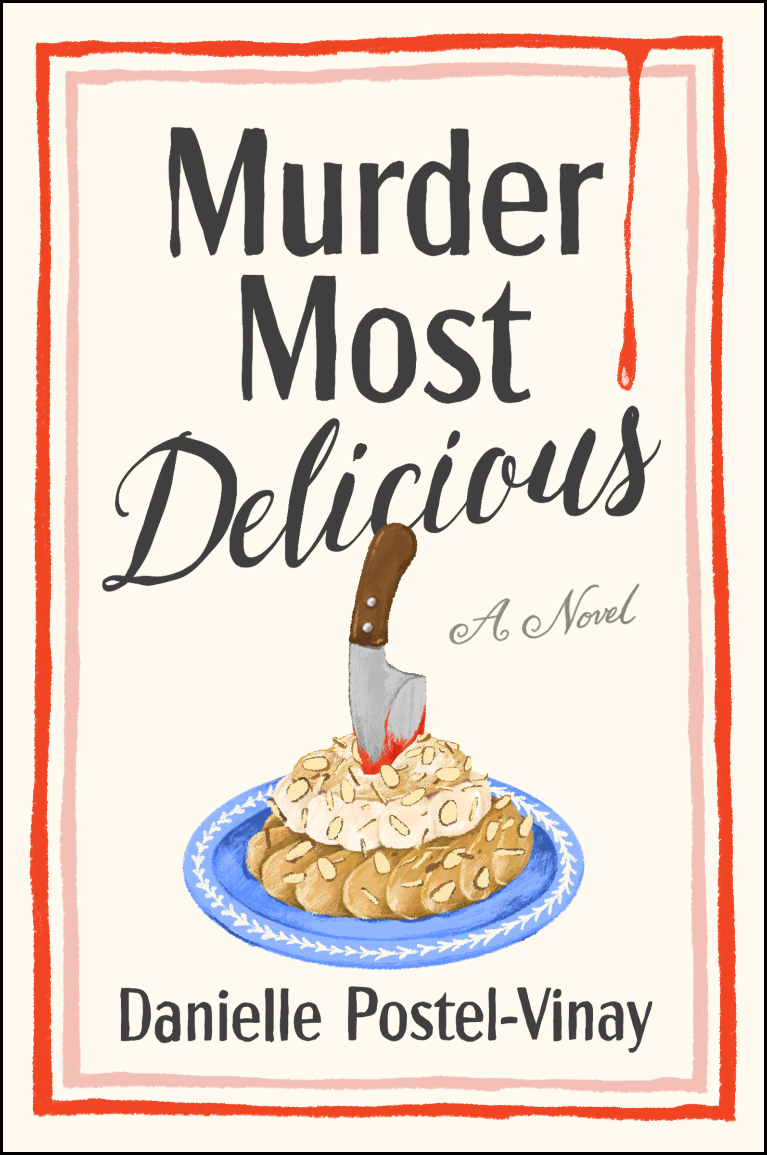
When American sommelier Olivia Beech loses her sense of taste and her promising career, an unexpected opportunity in Paris offers a chance to begin again. But her fresh start takes a deadly turn when a celebrated French chef is poisoned during her job interview, leaving Olivia the prime suspect. Armed with her extraordinary sense of smell, she joins forces with an eccentric neighborhood watch group led by a brilliant but agoraphobic detective. Together, this unlikely team of amateur sleuths sets out to uncover the truth. Filled with colorful characters, culinary delights, and Parisian charm, Murder Most Delicious is a witty and heartwarming mystery about friendship, resilience, and finding new purpose when life takes an unexpected turn.
Why it’s a Great Group Read
Murder Most Delicious offers book clubs a delightful combination of mystery, humor, friendship, and the pleasures of French food and culture. Set in a charming Parisian neighborhood, the novel introduces an eccentric cast of characters whose unexpected friendships celebrate the importance of community and found family. Olivia's journey invites conversations about resilience, trusting one's intuition, and finding new purpose when life takes an unexpected turn. The novel also explores the meaning of home, the connections forged through food, and the ways friendship and love can help us navigate difficult times. Its vivid descriptions of Parisian life, memorable characters, and engaging mystery provide plenty of opportunities for lively conversation. Unanimously recommended by our reviewers, Murder Most Delicious is an ideal choice for book clubs seeking a lighter read that celebrates hope, human connection, and the simple pleasures of life.

The Birthing Tree

Amanda Peters - Catapult
HC 9781646223695

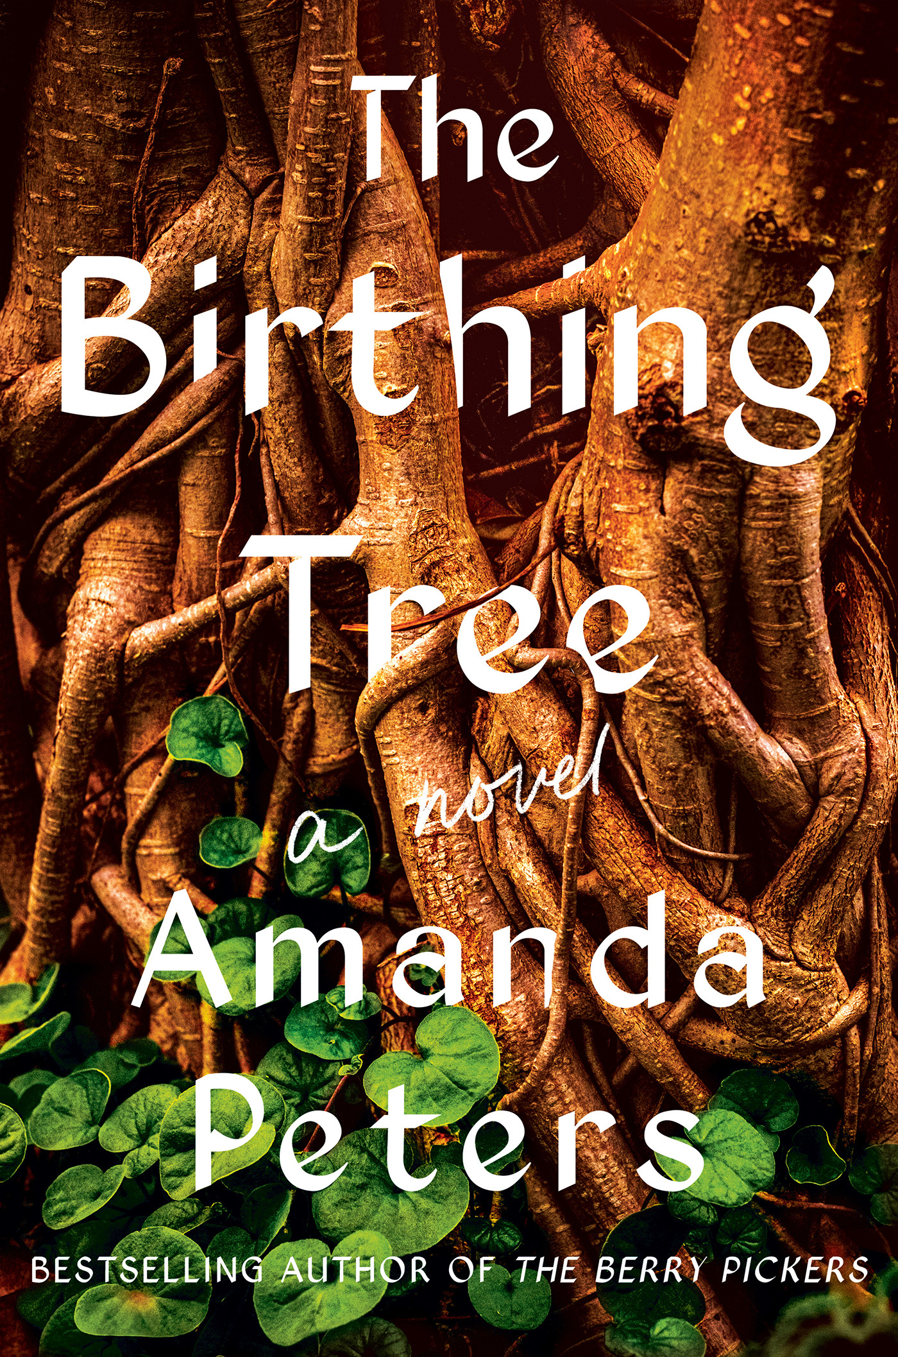
From the award-winning author of The Berry Pickers comes a moving novel about family secrets, cultural heritage, and the enduring bonds between generations of women. Born beneath a tree sacred to generations of Mi'kmaq women, Aliet Paul grows up in Nova Scotia under the loving guidance of her grandmother, Kiju, a traditional midwife. As Aliet comes of age, she struggles to reconcile her grandmother's teachings with a changing world that increasingly rejects Indigenous traditions. Years later, following her grandmother's death, Aliet returns home to confront the memories, unanswered questions, and family secrets she left behind. The Birthing Tree is a sweeping yet intimate story of love, loss, identity, and one woman's journey to reclaim her heritage and determine her own future.
Why it’s a Great Group Read
The Birthing Tree offers book clubs a beautifully written, multilayered exploration of Indigenous heritage, identity, resilience, and the enduring bonds between generations of women. Through Aliet's journey and her grandmother's traditional teachings, the novel invites thoughtful conversations about cultural preservation, family secrets, intergenerational trauma, and the connection between people and the land. The contrast between traditional Mi'kmaw midwifery and modern medical practices raises important questions about cultural authority, personal choice, and the consequences of imposing outside beliefs on Indigenous communities. Readers can also explore the complexities of mixed heritage, the strength of matriarchal families, and the ways love and loss shape our identities. The birthing tree itself, both a powerful symbol and a distinctive narrative voice, offers another fascinating dimension for discussion. The Birthing Tree combines memorable characters and lyrical storytelling with a wealth of meaningful topics, making it an exceptional choice for book clubs.

A Splintering

Dur E Aziz Amna - Dzanc Books
PB 9781938603778
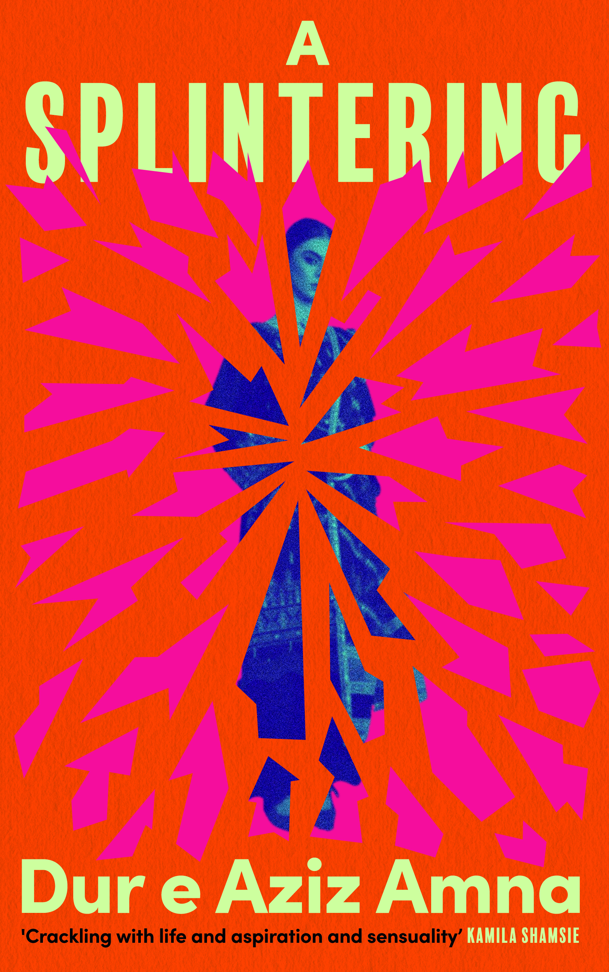
Growing up in rural Pakistan under the control of her violent brother, Tara dreams of escaping poverty and creating a better life. Marriage to a middle-class accountant offers her a way out, but her new life in the city only intensifies her hunger for wealth, independence, and social status. As her ambitions grow, Tara struggles with the competing demands of motherhood, marriage, and her determination to transcend her circumstances. Set against a backdrop of political turmoil and social inequality, A Splintering is a provocative portrait of a woman unwilling to accept the limitations imposed upon her. With psychological depth and unflinching honesty, Dur e Aziz Amna explores the complicated relationship between ambition, freedom, and the past we cannot escape.
Why it’s a Great Group Read
A Splintering offers book clubs a powerful exploration of ambition, class, gender, and the difficult choices women make in pursuit of independence. Set against the cultural and political landscape of Pakistan, the novel follows a determined woman whose desire for education, financial security, and a better life raises provocative questions about the relationship between survival and morality. Its complex protagonist invites readers to examine the contradictions between ambition and contentment, personal advancement and family loyalty, and sympathy and judgment. The novel also provides rich opportunities to discuss parent-child relationships, marriage, the expectations placed on women, and the tensions between tradition and modernization. Through its examination of economic inequality, political upheaval, and deeply rooted social hierarchies, A Splintering challenges readers to consider how much freedom individuals truly have when their choices are shaped by circumstances beyond their control. Beautifully written and emotionally compelling, it promises lively discussions and differing perspectives.

The Good Parts

Evann Normandin - Grand Central Publishing
HC 9781538780329
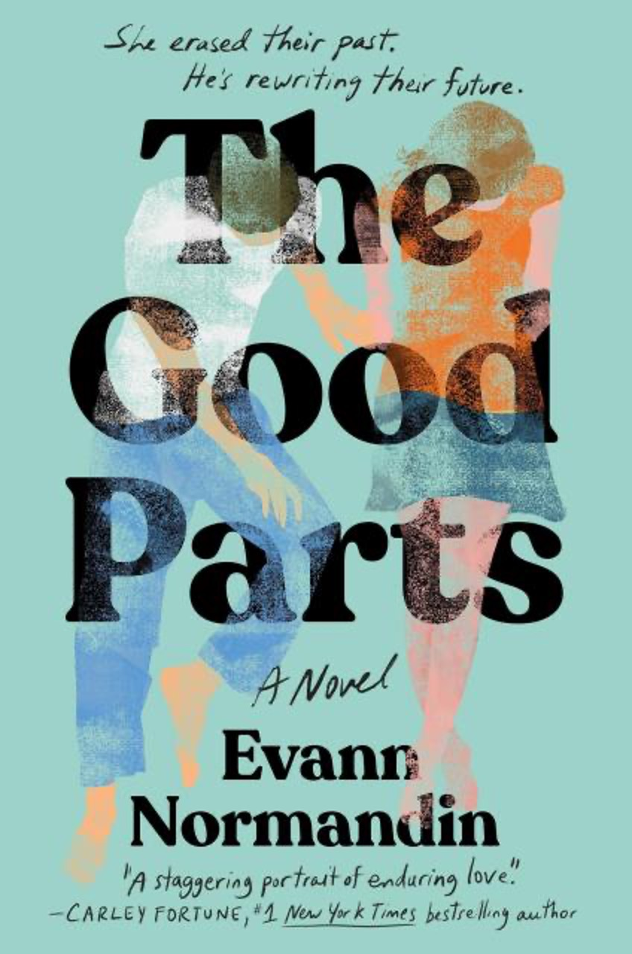
What if you could erase your most painful memories and begin again? In The Good Parts, Rose undergoes a radical memory-erasing treatment, leaving behind her grief, her marriage, and the man she once loved. But Landon cannot let go of their shared past. Determined to win her heart again, he follows Rose to Edinburgh, where she has built a new life, and reenters her world as a stranger. As their friendship develops, Landon carries the burden of memories Rose no longer possesses. Told through alternating timelines, Evann Normandin's emotionally compelling debut explores love, loss, memory, and the complicated choices we make when confronted with heartbreak.

Why it’s a Great Group Read
The Good Parts presents book clubs with an intriguing question: If you could erase your most painful memories and begin again, would you? Through its imaginative premise and emotionally complex characters, the novel explores grief, love, identity, and the consequences of trying to escape the past. Rose's decisions invite readers to debate whether forgetting painful experiences offers genuine freedom or comes at the cost of the relationships and memories that make us who we are. The novel also raises compelling questions about second chances, personal responsibility, and whether love can endure beyond memory. Its alternating timelines add another dimension to the discussion, encouraging readers to consider how past experiences shape present choices. This thought-provoking debut novel is an excellent selection for book clubs willing to explore difficult moral dilemmas, challenge one another's perspectives, and consider whether embracing life's painful experiences is essential to appreciating its good parts.

We’re So Lucky to Live Here

Rachel Pastan - Delphinium Books
HC 9781953002778
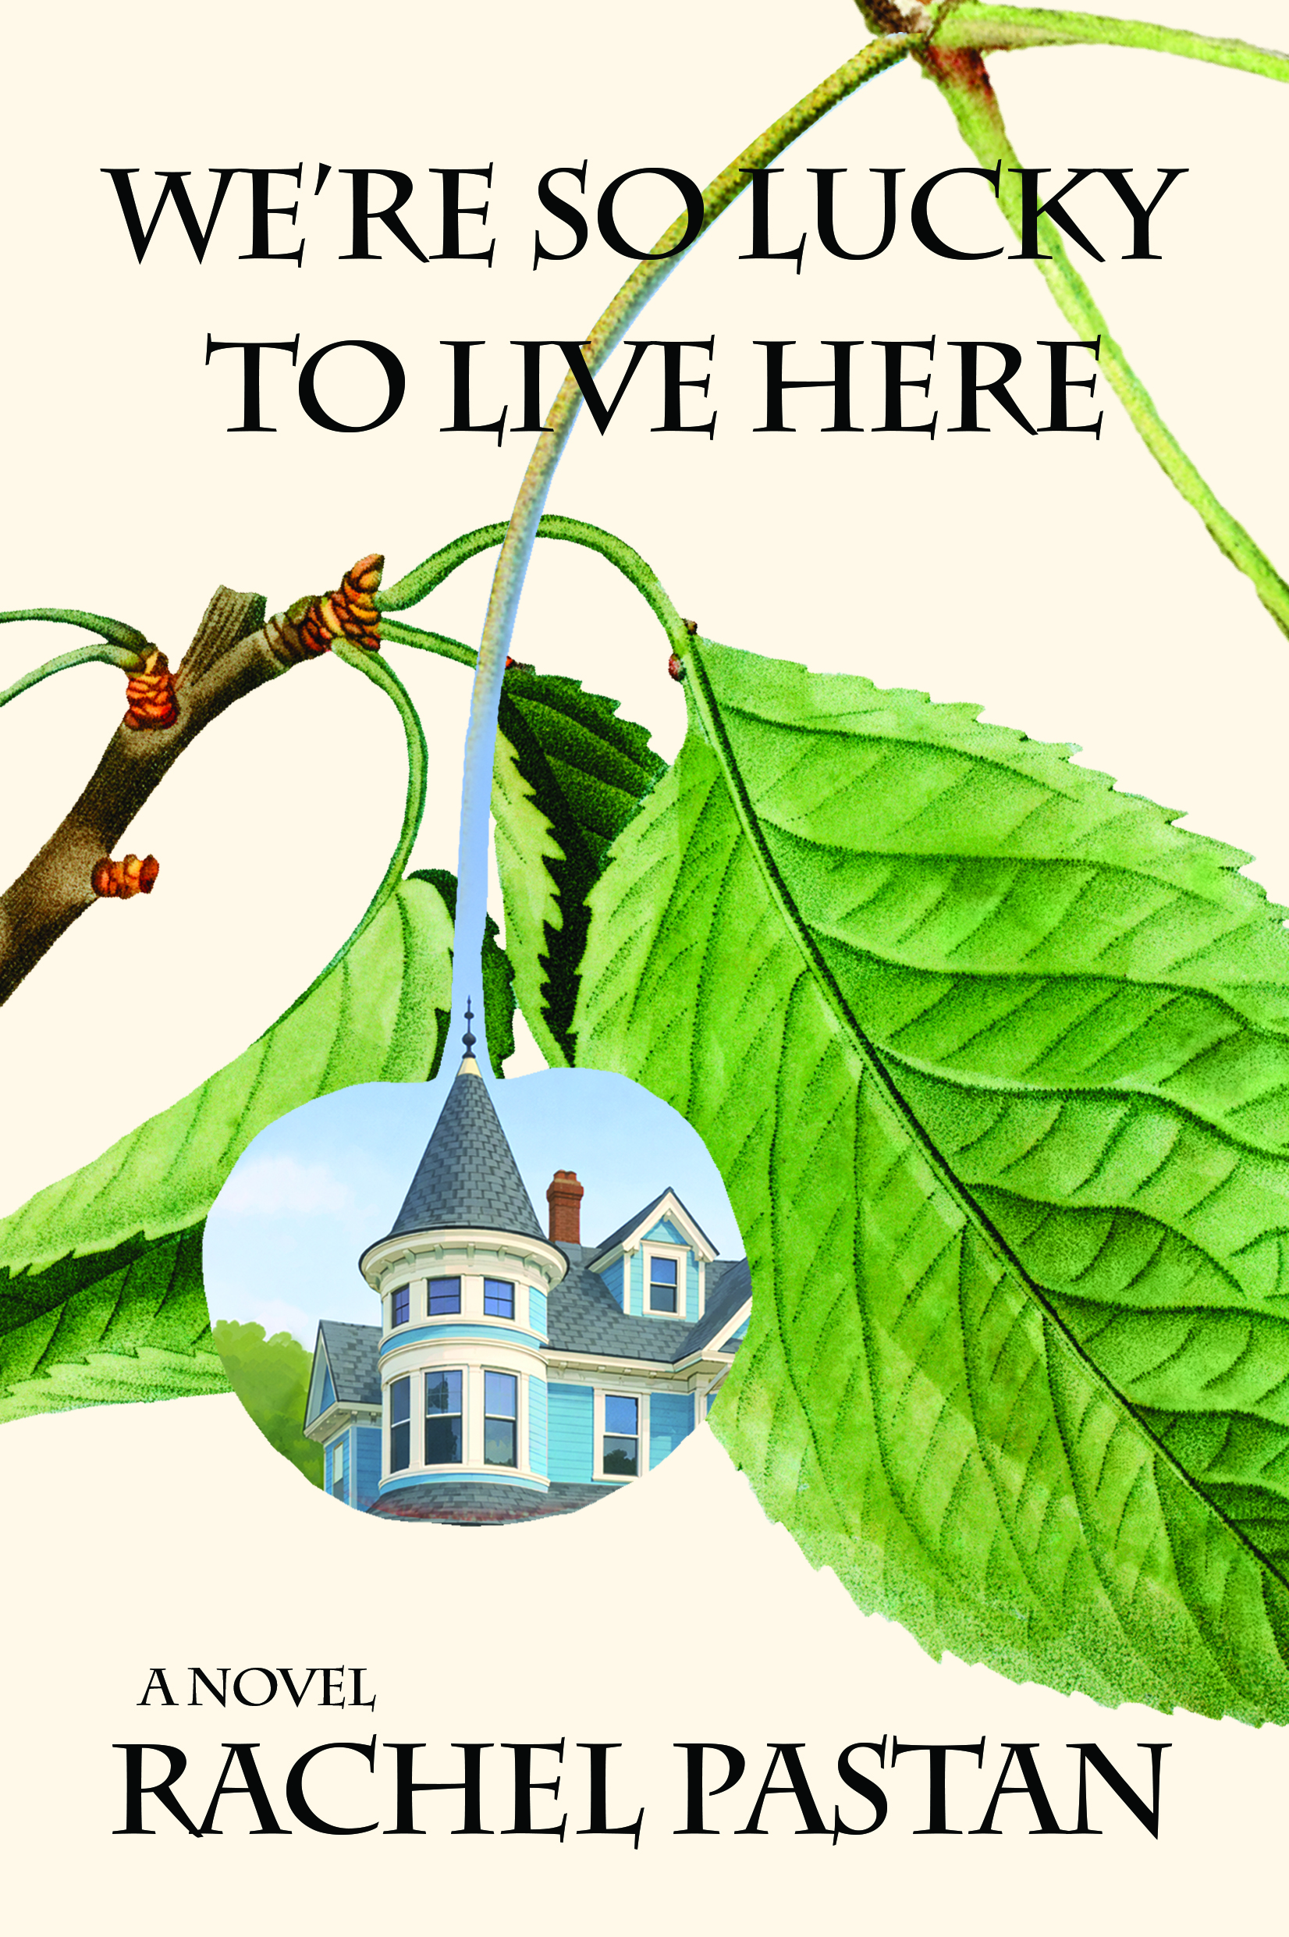
When twenty-seven-year-old theater director Gwen Rivlin returns to her childhood home following her mother's unexpected death, she inherits more than a beloved old house. She must confront complicated memories, unresolved family tensions, and the challenge of holding on to a home she cannot afford. Determined to stay, Gwen welcomes an unconventional collection of friends and housemates while navigating neighborhood opposition and restrictive zoning laws. Seeking comfort through creativity, she stages a production of Chekhov's The Cherry Orchard in her home, bringing together an unlikely cast of friends and neighbors. With warmth, humor, and emotional depth, Rachel Pastan explores grief, community, the transformative power of art, and the unexpected ways we create a place to belong.

Why it’s a Great Group Read
We're So Lucky to Live Here offers book clubs a moving and relatable exploration of family, grief, belonging, and the complicated meaning of home. Through its examination of mother-daughter relationships, childhood memories, and the emotional ties that bind us to people and places, the novel invites readers to consider what we choose to preserve and what we must learn to let go. Its exploration of housing affordability adds a timely dimension, raising questions about community, economic pressures, and who gets to call a place home. The novel also celebrates the transformative power of art and creativity, particularly through its theatrical production of The Cherry Orchard, offering opportunities to discuss how artistic expression can help us process loss and find connection. Above all, this warm and thoughtful novel encourages book clubs to explore what it truly means to belong and how the families we choose can become just as meaningful as those into which we are born.

Underlake

Erin L. McCoy - Doubleday Books
HC 9780385552073
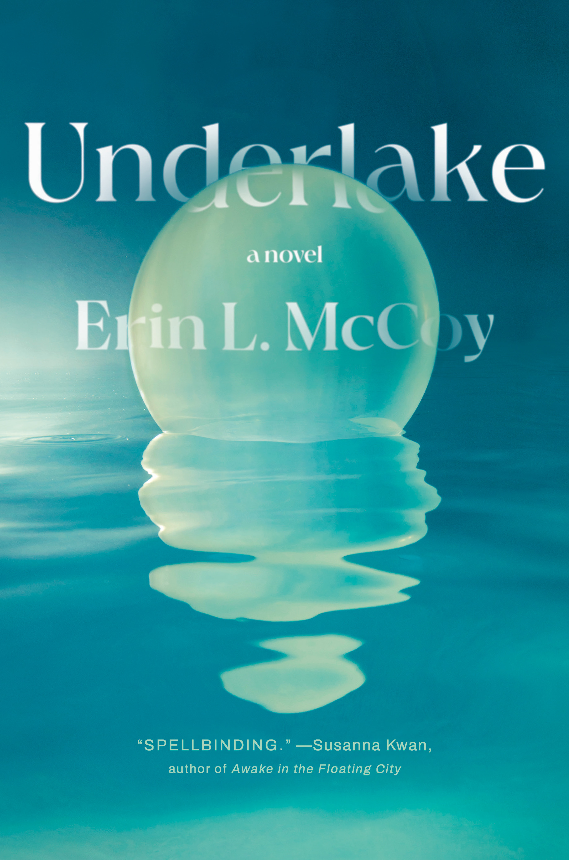
In this haunting and imaginative debut, marine biologist Otta returns to her hometown carrying the guilt of a tragic diving accident and uncertain about her future. When May, a desperate mother, asks for help finding her missing daughter, Otta is drawn into an extraordinary mystery beneath a nearby lake. Decades earlier, an entire valley was flooded to construct a dam, but some residents refused to abandon their homes. Now, the two women embark on a dangerous underwater journey into a hidden community where isolation, fear, and a determination to preserve the past have shaped an unsettling world. Blending literary fiction, suspense, and speculative storytelling, Underlake explores grief, forgiveness, and the powerful human desire to belong.

Why it’s a Great Group Read
Underlake offers book clubs an imaginative and thought-provoking exploration of family secrets, grief, motherhood, and the complicated relationships that bind communities together. Through its unusual underwater setting and elements of speculative fiction, the novel invites readers to consider how isolation, tradition, and the control of information can shape an entire community's understanding of its history. Its characters raise compelling questions about the consequences of withholding the truth, the lasting effects of misunderstandings, and the difficult choices people make to protect those they love. Themes of friendship, guilt, forgiveness, and resilience offer further opportunities to examine how individuals and communities recover from loss. With its distinctive setting and layered storytelling, Underlake encourages readers to question the stories they have inherited, reconsider their assumptions, and explore the delicate balance between loyalty and truth.

The Curious Calling of Leonard Bush

Susan Gregg Gilmore - Blair
PB 9781958888940

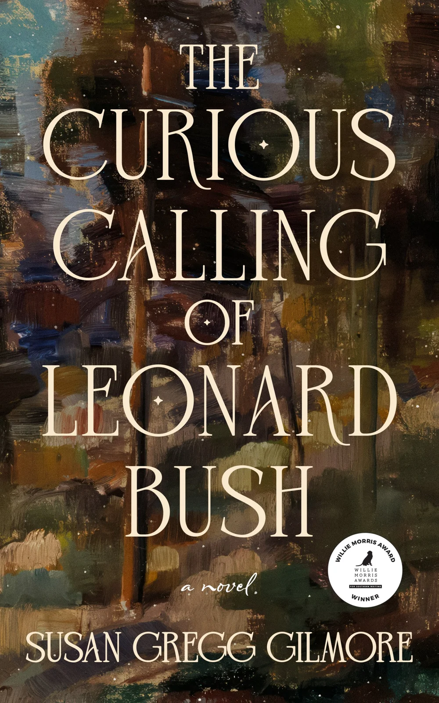
When twelve-year-old Leonard Bush loses his leg in a freak accident, he decides to give it a proper burial in his small East Tennessee town. What begins as an unusual act of mourning sets off a remarkable chain of events that transforms the lives of his family, friends, and neighbors. As Leonard's deeply religious mother, conflicted father, and best friend Azalea confront their own struggles, the community finds itself caught between faith, judgment, secrets, and the possibility of redemption. Set in the Appalachian South of the 1960s, The Curious Calling of Leonard Bush blends humor, heartbreak, and a touch of the miraculous in a moving story about resilience, compassion, and the unexpected ways one person can change an entire community.

Why it’s a Great Group Read
What if we could bury our mistakes and leave them behind? The Curious Calling of Leonard Bush gives book clubs an imaginative starting point for conversations about regret, forgiveness, faith, and second chances. Leonard's unusual calling raises questions that invite differing perspectives: Can we ever truly escape our past? Is forgiveness something we earn, something we give, or both? Through its engaging cast of characters and multiple points of view, the novel encourages readers to examine their own beliefs about guilt, redemption, and the complicated relationships between parents and children. Balancing humor and warmth with meaningful questions about human nature, this accessible and heartfelt story offers book clubs an opportunity to reflect on life's imperfections and the possibility of making peace with them.

Purgatoire

Liz Prato - Forest Avenue Press
PB 9781942436690

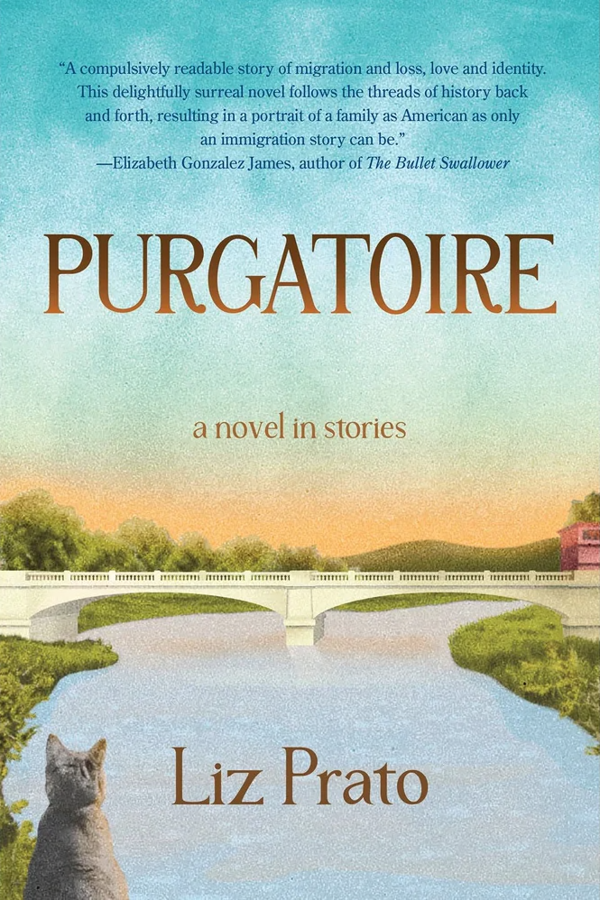
In 1910, Sabé Parella leaves northern Italy for the coal-mining communities of Colorado, hoping to reunite with her husband and build a better life. Instead, she arrives to discover that he has disappeared, leaving her to navigate an unfamiliar country and an uncertain future. Inspired by Liz Prato's own family history, Purgatoire follows generations of Italian immigrants as they confront discrimination, poverty, family secrets, and the complicated realities of the American dream. Told through interconnected stories that blend historical fiction with elements of magical realism, the novel explores the enduring consequences of choices made long ago. At its heart is a powerful story of women's resilience, family bonds, and the search for belonging across generations.

Why it’s a Great Group Read
How much do we owe our families, and how much do we owe ourselves? Purgatoire offers book clubs an intimate and thought-provoking exploration of the choices, secrets, and sacrifices that shape families across generations. Its interconnected stories invite readers to consider the immigrant experience, the lasting consequences of family secrets, and the tensions between personal desires, cultural expectations, and religious beliefs. Readers may find themselves debating the characters' decisions and reflecting on how our understanding of family history changes as we grow older. The novel's spiritual elements and symbolism open additional avenues for discussing guilt, forgiveness, redemption, and the meaning of belonging. Drawing on the author's own family history, Purgatoire also invites conversations about the relationship between memory, historical research, and fiction. Warm, accessible, and rich with opportunities for differing interpretations, it is a rewarding choice for book clubs interested in exploring the stories we inherit and the ones we choose to tell.

Backstitch

Marian Mitchell Donahue - Galiot Press
PB 9798998954764
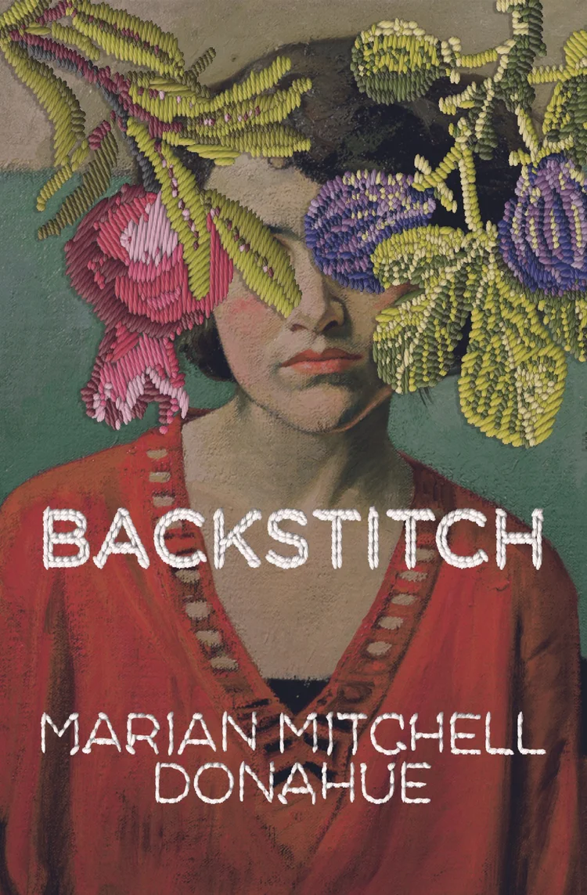
When sisters Violet and Marigold reunite at a retrospective exhibition of their late mother's artwork, they must confront the complicated legacy of a brilliant but troubled artist. Moving through the gallery's rooms, each piece of art reveals another layer of their mother's life, exposing family secrets, conflicting memories, and the personal costs of artistic ambition. As the sisters revisit their childhood and reconsider the woman they thought they knew, they grapple with the complicated relationships between art, motherhood, and family. With an inventive structure that moves between past and present, Backstitch is a richly layered exploration of creativity, memory, and the elusive nature of truth.

Why it’s a Great Group Read
Who owns a family's story, and who has the right to tell it? Backstitch offers book clubs a fascinating opportunity to explore the intersection of art, family relationships, and the secrets that shape our lives. Its inventive structure, built around a retrospective exhibition of an artist's work, encourages readers to examine the difference between what art reveals and the reality behind its creation. The novel raises provocative questions about artistic freedom and responsibility: Is it ethical to use children as artistic subjects, and who should control a portrait once it has been created? Its complex family relationships invite equally compelling discussions about biological ties, the meaning of parenthood, and the lasting consequences of family secrets. As each artwork reveals another piece of the family's history, readers may find themselves reconsidering their sympathies and interpretations. Beautifully written and thoughtfully constructed, Backstitch is an especially rewarding choice for book clubs interested in art, family dynamics, and the many ways we interpret the stories of those closest to us.

Obstetrix

Naomi Kritzer - Tordotcom
HC 9781250423375

In a chillingly plausible near future, Dr. Liz has just been acquitted of performing the last abortion in North Dakota when she is kidnapped by a fundamentalist religious cult desperate for an obstetrician. Held captive in an isolated compound, she is valued for her medical expertise but stripped of her freedom. As she witnesses the oppressive conditions endured by the women and girls around her, Liz faces an increasingly dangerous dilemma: how can she escape without abandoning those who desperately need her help? Combining the suspense of a medical thriller with the disturbing possibilities of dystopian fiction, Naomi Kritzer delivers a gripping story of courage, resistance, and the fight for bodily autonomy.

Why it’s a Great Group Read
How far does a physician's duty to patients extend when fulfilling that duty threatens their own safety? Obstetrix offers book clubs a gripping starting point for conversations about reproductive freedom, medical ethics, religious extremism, and personal autonomy. Its provocative premise invites readers to debate the obligations of healthcare professionals, the consequences of restrictive reproductive policies, and the ways seemingly appealing beliefs can become dangerous when taken to extremes. The novel also raises questions about the psychological pressures of living under constant surveillance, the manipulation of vulnerable individuals, and the difficult decisions people make when their survival is at stake. With its fast-paced storytelling and timely subject matter, Obstetrix provides an opportunity to examine complex ethical dilemmas while discussing how effectively a suspenseful thriller can illuminate contemporary social issues.

Good People

Patmeena Sabit - Crown Publishing Group
HC 9780593801062
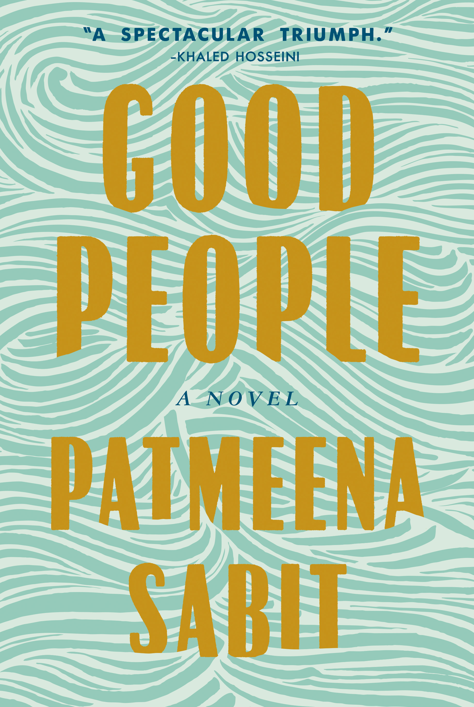
After fleeing war-torn Afghanistan, the Sharaf family builds a prosperous life in Northern Virginia, seemingly achieving the American dream. But when tragedy strikes their eldest daughter, Zorah, the family's carefully cultivated image begins to unravel. As friends, neighbors, relatives, and journalists offer conflicting accounts of the family's life, questions emerge about cultural expectations, family loyalty, and the truth behind closed doors. Told entirely through the voices of those surrounding the family, Good People is a gripping and provocative debut that blends literary fiction with the suspense of a mystery. Patmeena Sabit explores the immigrant experience, the complexities of identity, and the devastating consequences of assumptions and public judgment.

Why it’s a Great Group Read
How do we reconcile cultural traditions with individual freedom, and who gets to decide when those traditions become harmful? Good People offers book clubs an opportunity to explore these difficult questions through a compelling story that invites discussion long after the final page. Told through multiple perspectives in an oral-history format, the novel challenges readers to examine how personal beliefs, cultural expectations, and community loyalties shape our understanding of events. Its exploration of the immigrant experience raises timely questions about assimilation, generational conflict, parenting, and the struggle to preserve cultural identity while embracing new opportunities. Equally compelling are the conversations it invites about gender, domestic violence, religious beliefs, and the influence of public opinion. As readers encounter conflicting accounts, they may find their sympathies shifting and their assumptions challenged. With its thought-provoking structure, morally complex questions, and an ending open to interpretation, Good People is a particularly strong choice for book clubs seeking meaningful discussion and differing perspectives.

