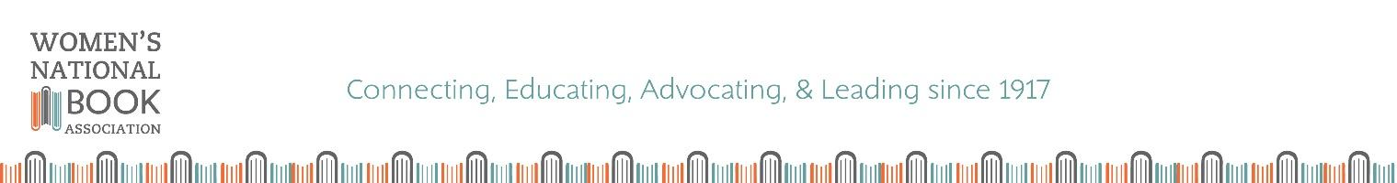

FOR IMMEDIATE RELEASE
August 18, 2026
Contact: Chair Susan Knopf
WNBAPannell@gmail.com

WOMEN’S NATIONAL BOOK ASSOCIATION RELAUNCHES
THE WNBA PANNELL AWARD
WITH CALL FOR NOMINATIONS

Since 1983, the Women’s National Book Association has awarded one of the most prestigious honors in children’s bookselling in the United States. After a pause following the Covid pandemic, the WNBA Pannell Award is relaunching this year. The award recognizes independent bookstores that enhance their communities by bringing exceptional creativity to foster a love of reading and books in children and young adults. The WNBA Pannell Award is co-sponsored by Penguin Young Readers Group. About the award, Emily Romero, SVP of Penguin Random House, says, “Penguin Young Readers is excited to support the WNBA Pannell Award and our indie booksellers.”

Every year a panel of publishing professionals selects two award winners: one general bookstore and one children’s specialty bookstore. Nominations come from customers, sales reps, bookstore owners or employees, or anyone who has been impressed with the work of a particular independent bookstore. Only one nomination is required for a bookstore to be considered.

There are two easy ways to nominate a bookstore for the WNBA Pannell Award.
- Complete the Online Nomination Form (https://forms.gle/T4GU2whX1CDEAyFr8)
- Email WNBAPannell@gmail.com and include the following:
  - Name, email address, and phone number of person making the nomination
  - That person’s connection to the nominated bookstore
  - Bookstore name, address, and contact information for the bookstore owner/manager
  - A brief statement outlining the reasons for nominating the bookstore

Nominations are due by September 30, 2026. Then the WNBA Pannell Award committee will reach out to all nominated bookstores to request a formal electronic submission. Submissions should include a description of programs, events, activities, goals, and any contributions to the bookseller’s local community that focus on connecting kids to the love of reading. Photos, media coverage, letters from customers, and other supplementary material may be included in the submission but are not required.

Once the WNBA Pannell Award jurors have reviewed all submissions, the winning bookstores will be notified by phone and all submitting bookstores will also receive a call. Each of the two winners will receive a $1,000 check and an original art piece from a children’s book illustrator. Details about the presentation of the award will be announced at a later date.

Along with WNBA, Penguin Young Readers Group co-sponsors the award, which was established in honor of Lucille Micheels Pannell, founding member of one of the WNBA chapters. Established in 1917, WNBA (www.wnba-books.org) is a national organization of women and men who promote the value of the written word by championing the role of women in the book community and by providing a forum for the exchange of ideas and information about book lovers and professionals.

